DUAL LED CHASER

Circuit diagram:

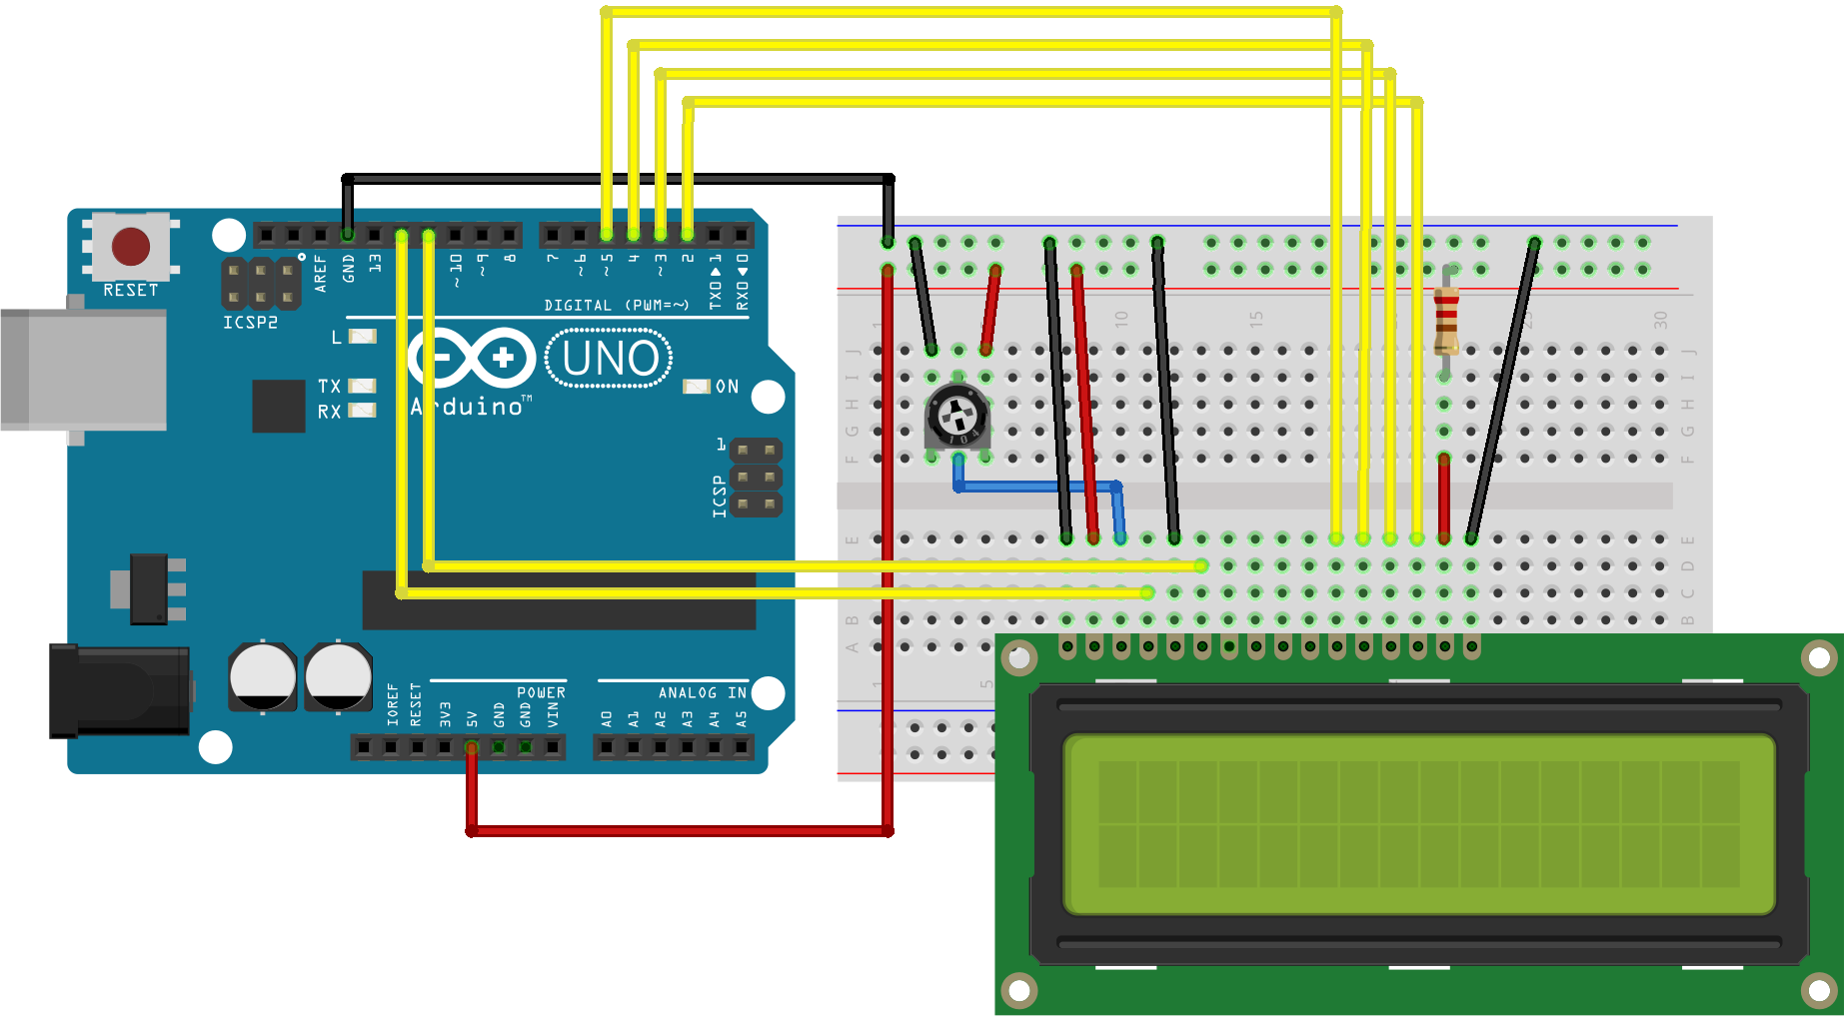

Theory:

CONCEPT USED:

➢ By using LED Display Module

➢ By using Arduino

➢ Series and parallel connections of wires and potentiometer

LEARNING AND OBSERVATIONS:

• Connections in Breadboard and wiring.

• How to control Data Display and its coding.

• Use of potentiometer

OBSERVATION:

➢ Data display on led

➢ Relation between software and hardware

PROBLEMS & TROUBLESHOOTING:

o To select the right port and type of arduino

o To check the loose connections

o To check the connections according to the codes

PRECAUTIONS:

o Handle Modules carefully

o Do not connect arduino till the circuit is complete

o Handle display carefully

OUTCOMES:

o Data is displayed on the Led Display.